EX – 6 a) FIRST COME FIRST SERVE
NAME : ENIYA B A
CLASS : CSE – A
ROLL NO : 230701085

Program:
#include <stdio.h>
int main() {
int n;
printf("Enter the number of processes: ");
scanf("%d", &n);
int burst_time[n], waiting_time[n], turnaround_time[n];
int total_burst_time = 0;
float total_waiting_time = 0, total_turnaround_time = 0;
printf("Enter the burst time of the processes:\n");
for(int i = 0; i < n; i++) {
scanf("%d", &burst_time[i]);
}
waiting_time[0] = 0;
for(int i = 1; i < n; i++) {
waiting_time[i] = burst_time[i-1] + waiting_time[i-1];
}
for(int i = 0; i < n; i++) {
turnaround_time[i] = burst_time[i] + waiting_time[i];
total_waiting_time += waiting_time[i];
total_turnaround_time += turnaround_time[i];
}
printf("\nProcess\tBurst Time\tWaiting Time\tTurnaround Time\n");
for(int i = 0; i < n; i++) {
printf("%d\t%d\t\t%d\t\t%d\n", i, burst_time[i], waiting_time[i], turnaround_time[i]);
}
printf("\nAverage waiting time is: %.2f\n", total_waiting_time / n);
printf("Average Turnaround Time is: %.2f\n", total_turnaround_time / n);
return 0;
}

OUTPUT :
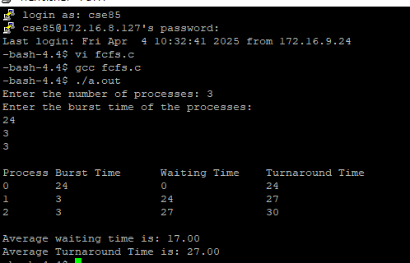

6 b) SHORTEST JOB FIRST

Program :

#include <stdio.h>

struct Process {
int pid;
int burst_time;
int waiting_time;
int turn_around_time;
};

void calculate_times(struct Process proc[], int n) {
int total_waiting_time = 0, total_turn_around_time = 0;
proc[0].waiting_time = 0;
proc[0].turn_around_time = proc[0].burst_time;

for (int i = 1; i < n; i++) {
proc[i].waiting_time = proc[i - 1].waiting_time + proc[i - 1].burst_time;
proc[i].turn_around_time = proc[i].waiting_time + proc[i].burst_time;
}

for (int i = 0; i < n; i++) {
total_waiting_time += proc[i].waiting_time;
total_turn_around_time += proc[i].turn_around_time;
}
float avg_waiting_time = (float)total_waiting_time / n;
float avg_turn_around_time = (float)total_turn_around_time / n;
printf("Process\tBurst Time\tWaiting Time\tTurn Around Time\n");
for (int i = 0; i < n; i++) {
printf("%d\t%d\t\t%d\t\t%d\n", proc[i].pid, proc[i].burst_time, proc[i].waiting_time, proc[i].turn_around_time);
}
printf("Average waiting time is: %.2f\n", avg_waiting_time);
printf("Average Turn Around Time is: %.2f\n", avg_turn_around_time);
}

int main() {
int n;
printf("Enter the number of processes: ");
scanf("%d", &n);
struct Process proc[n];
printf("Enter the burst time of the processes:\n");
return 0;
}

OUTPUT :
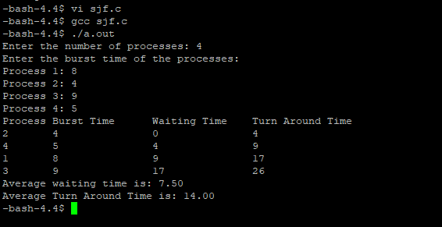

6 C) PRIORITY SCHEDULING
Program :
#include <stdio.h>

void calculateTimes(int processes[], int n, int burstTime[], int priority[], int waitingTime[], int turnaroundTime[]) {
int totalWaitingTime = 0, totalTurnaroundTime = 0;

waitingTime[0] = 0;
for (int i = 1; i < n; i++) {
waitingTime[i] = waitingTime[i - 1] + burstTime[i - 1];
totalWaitingTime += waitingTime[i];
}

for (int i = 0; i < n; i++) {
turnaroundTime[i] = burstTime[i] + waitingTime[i];
totalTurnaroundTime += turnaroundTime[i];
}
for (int i = 0; i < n; i++) {
printf("P[%d]\t%d\t\t%d\t\t%d\n", processes[i], burstTime[i], waitingTime[i], turnaroundTime[i]);
}

printf("\nAverage Waiting Time: %.2f", (float)totalWaitingTime / n);
printf("\nAverage Turnaround Time: %.2f\n", (float)totalTurnaroundTime / n);
}

void priorityScheduling() {
int n;
printf("Enter Total Number of Processes: ");
scanf("%d", &n);

int processes[n], burstTime[n], priority[n], waitingTime[n], turnaroundTime[n];

for (int i = 0; i < n; i++) {
processes[i] = i + 1;
printf("\nEnter Burst Time and Priority for Process P[%d]:\n", processes[i]);
printf("Burst Time: ");
scanf("%d", &burstTime[i]);
printf("Priority: ");
scanf("%d", &priority[i]);
}

for (int i = 0; i < n - 1; i++) {
for (int j = i + 1; j < n; j++) {
if (priority[i] > priority[j]) {
int temp = burstTime[i];
burstTime[i] = burstTime[j];
burstTime[j] = temp;

temp = priority[i];
priority[i] = priority[j];
priority[j] = temp;

temp = processes[i];
processes[i] = processes[j];
processes[j] = temp;
}
}
}
printf("\nProcess\tBurst Time\tWaiting Time\tTurnaround Time\n");
calculateTimes(processes, n, burstTime, priority, waitingTime, turnaroundTime);
}
int main() {
priorityScheduling();
return 0;
}

OUTPUT :
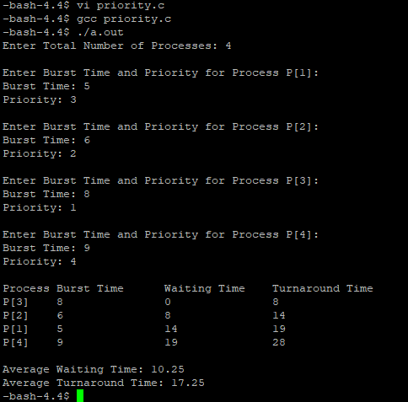

6 d) ROUND ROBIN SCHEDULING
Program:
#include<stdio.h>
int main()
{
int cnt,j,n,t,remain,flag=0,tq;
int wt=0,tat=0,at[10],bt[10],rt[10];
printf("Enter Total Process:\t ");
scanf("%d",&n);
remain=n;
for(cnt=0;cnt<n;cnt++)
{
printf("Enter Arrival Time and Burst Time for Process Process Number %d :",cnt+1);
scanf("%d",&at[cnt]);
scanf("%d",&bt[cnt]);
rt[cnt]=bt[cnt];
}
printf("Enter Time Quantum:\t");
scanf("%d",&tq);
printf("\n\nProcess\t|Turnaround Time|Waiting Time\n\n");
for(t=0,cnt=0;remain!=0;)
{
if(rt[cnt]<=tq && rt[cnt]>0)
{
t+=rt[cnt];
rt[cnt]=0;
flag=1;
}
else if(rt[cnt]>0)
{
rt[cnt]-=tq;
t+=tq;
}
if(rt[cnt]==0 && flag==1)
{
remain--;
printf("P[%d]\t|\t%d\t|\t%d\n",cnt+1,t-at[cnt],t-at[cnt]-bt[cnt]);
wt+=t-at[cnt]-bt[cnt];
tat+=t-at[cnt];
flag=0;
}
if(cnt==n-1)
cnt=0;
else if(at[cnt+1]<=t)
cnt++;
else
cnt=0;
}
printf("\nAverage Waiting Time= %f\n",wt*1.0/n);
printf("Avg Turnaround Time = %f",tat*1.0/n);
return 0;
}

OUTPUT :
